Primary Sources: Images of Civil War Soldiers

Compare the two images of Civil War soldiers and their captions. What are similar and different between the two? What message does each depiction communicate?
Depictions | Captions & Your Observations
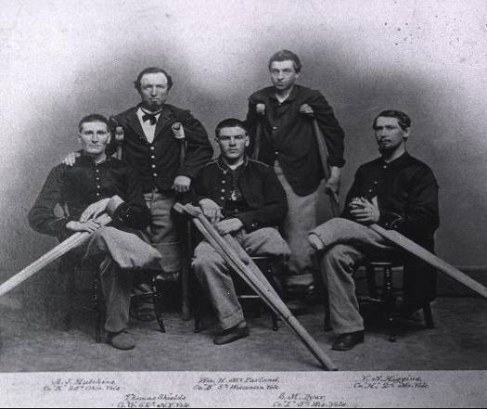 | Soldiers at Armory Square Hospital, Washington DC, 1860s  Courtesy National Library of Medicine
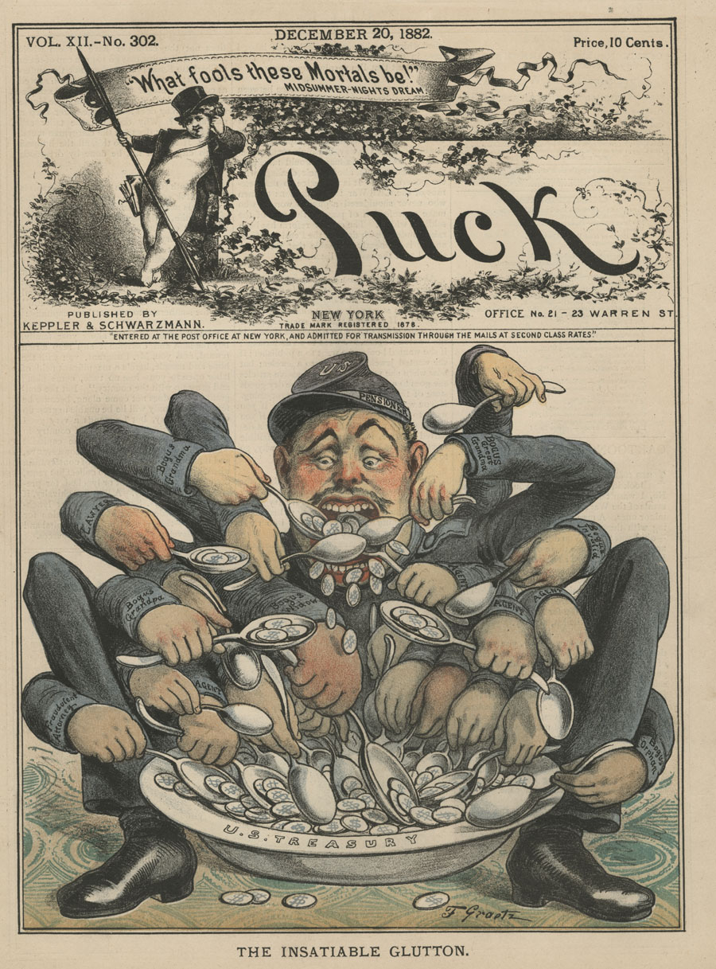 | Puck magazine, 20 December 1882  Courtesy National Library of Medicine

